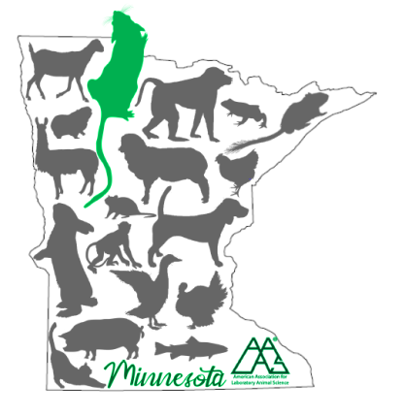

7:00 Registration opens
7:30 Refreshments

8:00 Welcome

8:05 Learning Styles: Fact or Fiction
Stacy Pritt, DVM, MS, MBA, CPIA, CHRC, DACAW
Assistant Vice President Conflict of Interest & Institutional Animal Care and Use Committee
Faculty Associate in Psychiatry (Ethics Division)
University of Texas Southwestern Medical Center

8:50 Vendor Spotlight
Terry Burns-Heffner, Shepherd Specialty Papers
Minnesota AALAS Enrichment and

9:00 Implementation of Active Learning into Animal Care and Use Training Programs
Kiirsa Pokryfke, MS, CMAR, LATG
ULAM Training Core Manager, University of Michigan

10:00 Break, Vendor Booths

10:30 Vendor Spotlight
Mark Lane, Tecniplast USA

10:40 Online Training in a Hands-On Field: Incorporating Training into an Animal Care Program
Shannon May, CVT, RLAT
Training Coordinator, Research Animal Resources, University of Minnesota

11:25 Lunch sponsor presentation: Introduction of a-tune and tick@lab Animal Facility Software
Patrick Guider, a-tune

11:55-12:45 Lunch, Vendor Booths

12:45-1:45 Training Platforms
“The Chip Clip: A Calming Restraint for Mice”
Krista Thompson, Training Specialist
Mayo Clinic

“Surgical training program for core laboratory personnel and investigators”
Megan Swaab Fine, DVM, MS, DACVS-LA, DACLAM
Principal Veterinarian
Boston Scientific

“Training on tumor endpoints”
Thomas Meier, DVM MBA DACLAM
Attending Veterinarian, Mayo Clinic

“Establishment of a Rodent Surgery Training Program”
Melissa Primitivo, DVM
Laboratory Animal Medicine Resident
Mayo Clinic

1:45 Vendor Spotlight
Marc Wohlfeil, Allentown

1:55-2:40 Compassion Fatigue: Bringing Awareness to the Team
Travis Miles, BS, NREMT
Lead Supervisor, Research Animal Resources, University of Minnesota

2:40-3:10 Break, Vendor Booths

3:10-4:10 The Joy of Training with Translational Training ToolsTM; implementing the 3 Rs for effective, low stress, hands-on training
Wendy Williams
Assistant Director, Training Services; Clinical Veterinarian, Uris Hall, Corson Mudd
Section Chief, Laboratory Animal Medicine Service; Adjunct Professor, Dept of Biomedical Sciences
Center for Animal Resources and Education (CARE), Cornell University

4:10 Concluding Remarks

